SAGIN’S routing network awareness

Alec Mabhiza Chirawu, *Student Number: M202161021*

***Abstract*—A lot of research is done to tackle the challenges of high-performance and energy-efficient data center networking. Use of wireless links for DCNs to eliminate these disadvantages is an important research topic. Aerospace-based communications can be managed more efficiently through the construction of an integrated space/air information network. Such a network would best fit the advent of delay- and disruption-tolerant networking, such as under a store-carry-forward mechanism. A novel ACO-based cross-layer routing algorithm for space-air- ground integrated networks (SAGINs) is proposed. We show how to design a routing paradigm that accounts for traffic conditions at a node. The resulting algorithm routes around congested areas while preserving the desirable properties of IP routing mechanisms. Our simulations indicate significant improvements in end-to-end delay and jitter when compared to standard shortest path routing algorithms.**

***Index Terms*—** **SAGINS, routing awareness**

1. INTRODUCTION

**E**

ND-TO-END techniques, such routing for best effort traffic, have historically been used to control congestion

on the Internet. Even though there may be alternate channels open, each stream receives just a portion of the bandwidth when many traffic streams share a bottleneck link. This queueing latency may vary depending on the flow of traffic, increasing jitter. Circuit-based routing combined with traffic engineering approaches can address the issue of end-to-end latency and jitter. In this scenario, calculations are carried out along pre-calculated pathways with the assumption that the traffic demands between source-destination pairs are known a priori. In this research, we propose an alternative steepest gradient search-based approach for traffic-aware routing. The Internet’s concept of hop-by-hop routing is preserved via PB- routing, which does not need previous knowledge of node- to-node traffic requests. It can adjust to changes in traffic circumstances without needing a global recalculation of routes since packets are not source routed. By making the potential at each NE a weighted sum of the potential for the shortest path plus a measure that symbolizes the potential for traffic at the NE, the PB-routing algorithm may be made traffic-aware. The routing algorithm sees the entire network as a landscape with numerous congested barriers that may be overcome.

In this paper, we describe the design of a potential field for traffic-aware routing that guarantees desirable properties such as loop-free routing. In our simulations, we have observed significant improvements in end-to-end delay and jitter over a

*Manuscript received November 30, 2022.This paper is an expanded paper from Information and Engineering Department. Digital Communication course held on September 13 - November 30, 2022 in University of Science and Technology, Beijing.*

*A. Mabhiza Chirawu is with the Department of Information and Commu- nication Engineering, University of Science and Technology Beijing, Bejing, China (e-mail:* [*m202161029@xs.ustb.edu.cn*](mailto:m202161029@xs.ustb.edu.cn)

variety of networks and traffic conditions without requiring too much control overheads. We believe that the general framework could be adapted for optimizing various other metrics through careful design of potential functions. In this article, we outline the architecture of a possible field for traffic- aware routing that ensures desirable qualities including loop- free routing. In our simulations, we have seen substantial reductions in end-to-end jitter and latency across a range of networks and traffic situations without the need for excessive control overheads. Through careful design of alternative func- tions, we think the overall architecture might be modified for maximizing a number of different measures.

1. OVERVIEW - ROUTING WITH POTENTIALS Algorithms have been developed to optimize network delays

and loss rates. One of the earliest works in this area was

Gallager’s minimum-delay routing algorithm [10]. Another class of algorithms uses link utilization as a measure of traffic and attempts to minimize the maximum (or worst-case) link utilization, given a set of point-to-point traffic demands. We believe that it is possible to use PB-routing with the methods described in this work to route the long-lived flows. The steepest gradient search technique has previously received much research. Numerous optimization problems have been solved using this approach, and it has been utilized in a variety of fields including path planning in robotics, artificial intelligence, and monte-carlo simulations in statistical physics. The fundamental goal of steepest gradient search is to find the best point for a (non-linear) function by first evaluating it at a starting point and then making incremental steps in the steepest gradient’s direction. The area of traffic-aware routing (i.e., routing techniques that take into account traffic conditions) has been studied extensively both from both practical and theoretical perspectives. In our work, we have adapted this method to identify the direction in which to route packets in a data network such that highly congested areas in the network are avoided. This is accomplished by assigning carefully designed potentials based on traffic experienced at a network node. We believe it is possible to use PB-routing with the methods described in this work to route the long-lived flows. Almost all of the algorithms that have been developed require a point-to-point traffic demand matrix to be specified.

One class of algorithms uses link utilization as a measure of traffic and attempts to minimize the maximum (or worst- case) link utilization. Another technique is to reduce delay by assigning static OSPF link weights based on a known traffic demand matrix.

1. *Multipath QoS routing*

Multi-path QoS aware routing enhances information ex- change in the SAGIN ecosystem despite utilizing a single

transmission performance indicator. To improve high arrival rate and very low latency aware data transfer, 6G-SAGIN must provide multi-path routing between two operation centers. Such routing can be calculated at operation centers on the ground or in the air. Later, pre-computed routing policy is re- viewed in order to modify QoS requirements to meet SAGIN’s needs. Utilizing numerous connection resources allows load balancing to be carried out among several operation centers. Pre-computing on-board systems located at ground, aerial, or satellite centers and real-time computing on board should be separated into two phases in 6G-SAGIN multipath QoS routing. There are three main processes in pre-computation, such as creating the position and ISL knowledge repository based on the position information that is currently accessible and an ISL log. Additionally, it combines near- real time feedback ISL with the potential QoS demand and traffic persistence, as well as forecast of satellite position in the following slot (e.g., bandwidth availability, delay, etc.).

1. *Combined routing*

6G-SAGIN would be benefited by involving the hierarchical routing (HR) algorithm. The HGHR outperforms traditional DTN, topology characterization and predicted node movement mechanisms. It is capable of predicting the UAV position, contact time, contact probability, sojourn time probability, and state transition probability [19].

1. *Joint service placement routing*

SAGIN’s QoS is enhanced by carefully choosing the path to the routing services. In order to address these issues, 6G- SAGIN would use pre-sent air-to-ground (A2G) and direct- A2G (DA2G) connectivity. In A2G or DA2G networks, there are three key variables that might change: cost, bandwidth, and latency [17,18]. The JSPR’s ability to support two different modes, such as static and mobility-aware, can greatly reduce the overall cost. By putting virtual computers (VMs) in the issue area, the approach is further enhanced.

1. LIMITATIONS

Early routing systems for satellite networks interpreted the deterministic network as a long sequence, turning the dynamic routing issue into a static one. however there hasn’t been any effort to create an integrated network with reliable and prescriptive subnetworks. The routing issue in DTN networks made up of numerous classes of nodes with various features and traffic conditions was explored by the authors in [19] but left unsealed due to routing-awareness variants.

1. METHODOLOGY

We go through our adopted process in detail below. Numerous heuristic techniques have been put forth by researchers to enh-ance routing speed and reduce resource overhead. The two most often employed methods were Direct Transmission [12] and Ep-idemic Routing[13]. When a client sends an IP packet, the switch inspects the packet and, in accordance with any co-nfigured policies or rules, passes the packet via a specific route. Probabi-lity estimate is the foundation of the Probabilistic Routing Protocol utilizing History of Encounters and Tran-sitivity (PROPHET) [16]. The packet is sent to the controller if the switch has no installed policies or rules. After identifying the type of packet and inspecting the packet header and/or payload, the controller puts a policy or rule on the switch instructing it to forward packets via a certain path. Based on their past contact frequency, each node would calculate its P-value, or likelihood of reaching the specified destination as shown in fig 1.

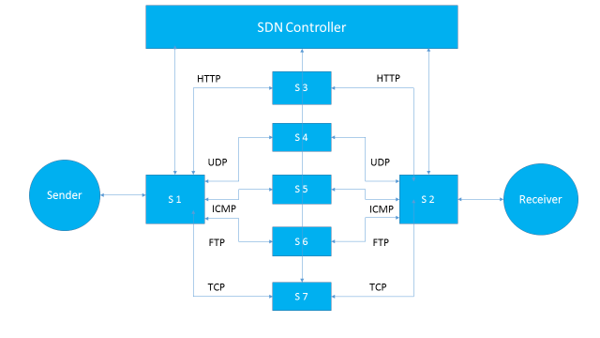

Fig. 1. Routing distribution of data from sender to receiver using classified TCP traffic into HTTP and FTP traffic which are assigned to dedicated path in [9],[13],[19].

1. *Implementation*

A packet follows the shortest route between its source and its destination when using the conventional shortest path techniques. Usually, well-known techniques (like Dijkstra's shortest path algorithm) may be used to calculate shortest pathways. Let p represent a packet traveling from node v to node w, and let be the length of the shortest path between nodes v and w in the network graph. We choose a single-valued, monotonically rising, linear function of x called V (x) as the potential at node v. A packet p at node v chooses the next hop w to reach destination d in a way that, in the absence of topology changes, the force is maximal and positive since the potential function V is single-valued and time invariant everywhere. We first establish the following lemma to demonstrate that each packet p finally reaches its destination. In case a node fails and is stopping or slowing down network traffic, the network will need to adjust and build connections. The network must be able to recognize when a node v or connection has failed and remove it from the list of nodes and links that are currently alive and functioning.

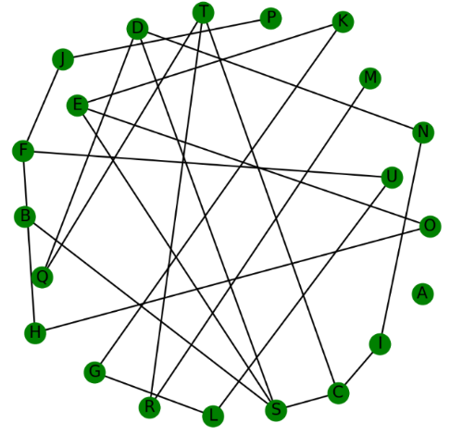

Fig. 2. Shortest path on dynamic routing avoiding defective network nodes or links to make sure safe delivery of packets.

1. *Route awareness results*

The Using the conventional scheme measure provided by [3],[9],[11],[21] represent the real and estimated channel parameter vectors, and [x]l derived from the parameters. The performance of the first route estimation is first assessed using the base [13]. The routing precision-based communication channels with fast time-varying fading characteristics are not suited for the state-of-the-art channel estimation and tracking techniques [2],[10], [14] for angle estimation at every SNR point. Routing precision ranges are roughly matching to the approximate beam sweeping estimations method which is set at the best in routing awareness obtained by [20]. BP Algorithm[4] also provide fast packets delivery proportion to the routing precision.

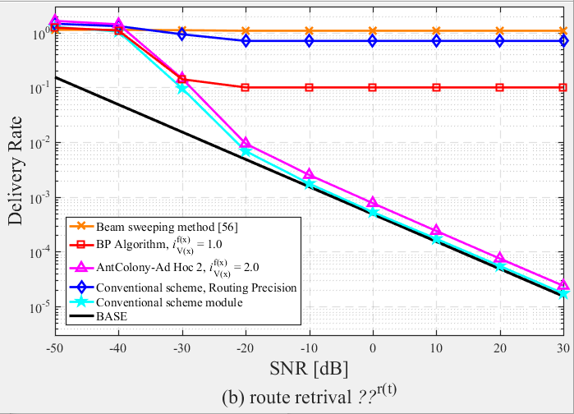

Fig. 3. *Routing awareness measurement block diagram. The rate at which routes are allocated given the amount of SNR on the network from point A to B.*

The precision of the routing also decreases as the speed and distance increase due to the rate at which the routes are allocated. The precision of ant colony route retrieval is increased in terms of speed from point A to point B since it takes more time. The suggested approach suffers considerably from being unaware of any change in route weakness or disjoint, in contrast to an ant colony that uses a filter mechanism to prevent connecting to weak routes.

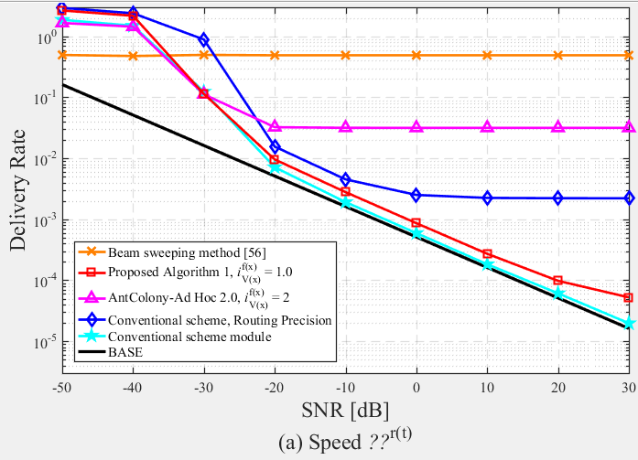

Fig. 4. *Time-domain measurement block diagram. The rate at which packets is delivered given the amount of SNR on the network from point A to B.*

1. CONCLUSION

A cross-layer routing method for SAGINs is proposed to counter routing awareness problem. The heterogeneous networks are described by a topology with parameters providing physical channel information. In addition, the end-to-end latency of nodes is inferred and estimated through the use of queuing theory. The suggested technique delivers packets but with little propagation delay. The suggested approach is effective on recognizing routes, but suffer from decision making compared to ant colony which take more time to filter the network but deliver all the packets on time.

The experimental results show that good agreement can be reached between Ant colony,[3],[4] and ARPANET. A lot of work remains to be solved on the proposed algorithm to achieve effective results in routing awareness and transmitting speed.

ACKNOWLEDGMENT

The author thanks Professor Dù bīng for the opportunity and GitHub for giving me access to relevant codes from other scholars.

REFERENCES

1. F. Z. Liu J, Shi Y, “Space-air-ground integrated network: a survey.” *IEEE Wireless Communications 27.6:68–74*, 2018.
2. Z. Y. Lyu F, Wu F, “Virtualized and micro services provisioning in space- air-ground integrated networks.” *IEEE Wireless Communications*, 2020
3. Li YQ, Wang Z, Wang QW (2018) Reliable ant colony routing

algorithm for dual-channel mobile ad hoc networks. Wirel Commun Mob Comput 104(4):1433–1471.

1. K. N. Malar ACJ, Kowsigan M, “Multi constraints applied energy efficient routing technique based on ant colony optimization used for disaster resilient location detection in mobile ad-hoc network.” *Journal of Ambient Intelligence and Humanized Computing 20:1–11*, 2020.
2. H. Z. Zhi T, “An improved ant colony routing algorithm for wsns.” *J Sensors 15:1–4*, 2015
3. Zhou J, Tan H, Deng Y, Cui L, Liu D (2016) Ant colony-based energy

control routing protocol for mobile ad hoc networks under different node

mobility models. EURASIP J Wirel Commun Netw 16:1–8

1. Zhou, Z., Feng, J., Zhang, C., Chang, Z., Zhang, Y., Huq, K.M.S., 2018. SAGECELL: Software-Defined Space-Air-Ground Integrated Moving Cells. IEEE Commun. Magazine 56 (8), 92–99. https://doi.org/10.1109/MCOM.2018.
2. Zhou, S., Wang, G., Zhang, S., Niu, Z., Shen, X.S., 2019. Bidirectional Mission Offloading for Agile Space-Air-Ground Integrated Networks. IEEE Wireless Commun. 26 (2), 38–45. <https://doi.org/10.1109/MWC.2019.1800290>.
3. J. McQuillan, I. Richer and E. Rosen, "The New Routing Algorithm for the ARPANET," in IEEE Transactions on Communications, vol. 28, no. 5, pp. 711-719, May 1980, doi: 10.1109/TCOM.1980.1094721.
4. D. Bertsekas and R. Gallager. Second Derivative Algorithm for Minimum Delay Distributed Routing in Networks. IEEE Transactions on Communications, 32(8):911–919, 1984
5. E. J. Anderson, T. E. Anderson, S. D. Gribble, A. R. Karlin, and S. Savage. A Quantitative Evaluation of Traffic-Aware Routing Strategies. ACM SIGCOMM Computer Communication Review, 32(1):67–67, January 2002.
6. T. D. Tlsty and P. W. Hein, ‘‘Know thy neighbor: stromal cells can contribute oncogenic signals,’’ Current Opinion Genet. Develop., vol. 11, no. 1, pp. 54–59, Feb. 2001.
7. A. Vahdat and D. Becker, ‘‘Epidemic routing for partially connected ad hoc networks,’’ Dept. Comput. Sci., Duke Univ., Durham, NC, USA, Tech. Rep. CS-200006, 2000. [Online]. Available: <ftp://sweb.cs.duke.edu/dist/techreport/2000/2000-06.ps>.
8. R. Diana, E. Lochin, L. Franck, C. Baudoin, E. Dubois, and P. Gelard, ‘‘A DTN routing scheme for quasi-deterministic networks with application to LEO satellites topology,’’ in Proc. IEEE Veh. Technol. Conf. (VTC Fall), Sep. 2012, pp. 1–5.
9. V. Erramilli, M. Crovella, A. Chaintreau, and C. Diot, ‘‘Delegation forwarding,’’ in Proc. ACM Int. Symp. Mobile Ad Hoc Netw. Comput., May 2008, pp. 251–260.
10. A. Lindgren, A. Doria, and O. Schelén, ‘‘Probabilistic routing in intermittently connected networks,’’ ACM SIGMOBILE Mobile Comput. Commun. Rev., vol. 7, no. 3, pp. 19–20, Jul. 2003.
11. Poularakis, Konstantinos and Llorca, Joint Service Placement and Request Routing in Multi-cell Mobile Edge Computing Networks, <https://doi.org/10.48550/arxiv.1901.08946>.
12. Binbin Yuan, Songtao Guo, Quyuan Wang, Joint service placement and request routing in mobile edge computing, Ad Hoc Networks, Volume 120, 2021, 102543, ISSN 1570-8705, <https://www.sciencedirect.com/science/article/pii/S1570870521000925>.
13. S. Narayan, J. Paulos, S. W. Chen, S. Manjanna and V. Kumar, "Combined Routing and Scheduling of Heterogeneous Transport and Service Agents," 2021 IEEE/RSJ International Conference on Intelligent Robots and Systems (IROS), 2021, pp. 1466-1472, doi: 10.1109/IROS51168.2021.9636684.
14. <https://www.mathworks.com/content/dam/mathworks/mathworks-dot.com/images/responsive/supporting/campaigns/offers/5g-beam-management-white-paper/5g-beam-management-white-paper.pdf>
15. Istikmal and Kurniawan, Adit and Hendrawan, 2015 1st International Conference on Wireless and Telematics (ICWT), Throughput performance of routing protocols based on SNR in wireless mobile ad hoc networks, 2015,1-6,10.1109/ICWT.2015.7449226.